**Introduction**

Based on GUI interface, crawl, data processing, visual display can be music search, music playback, music download, music collection, lyrics display, lyrics cloud, current hot song view, current hot singer, data analysis view a software.

**Environmental statement**

Computer system version: Windows11

Python version: python 3.11.2 and python3.13.0

Running on: pycharm2023.1.4 or Visual Studio Code

**Imported library**

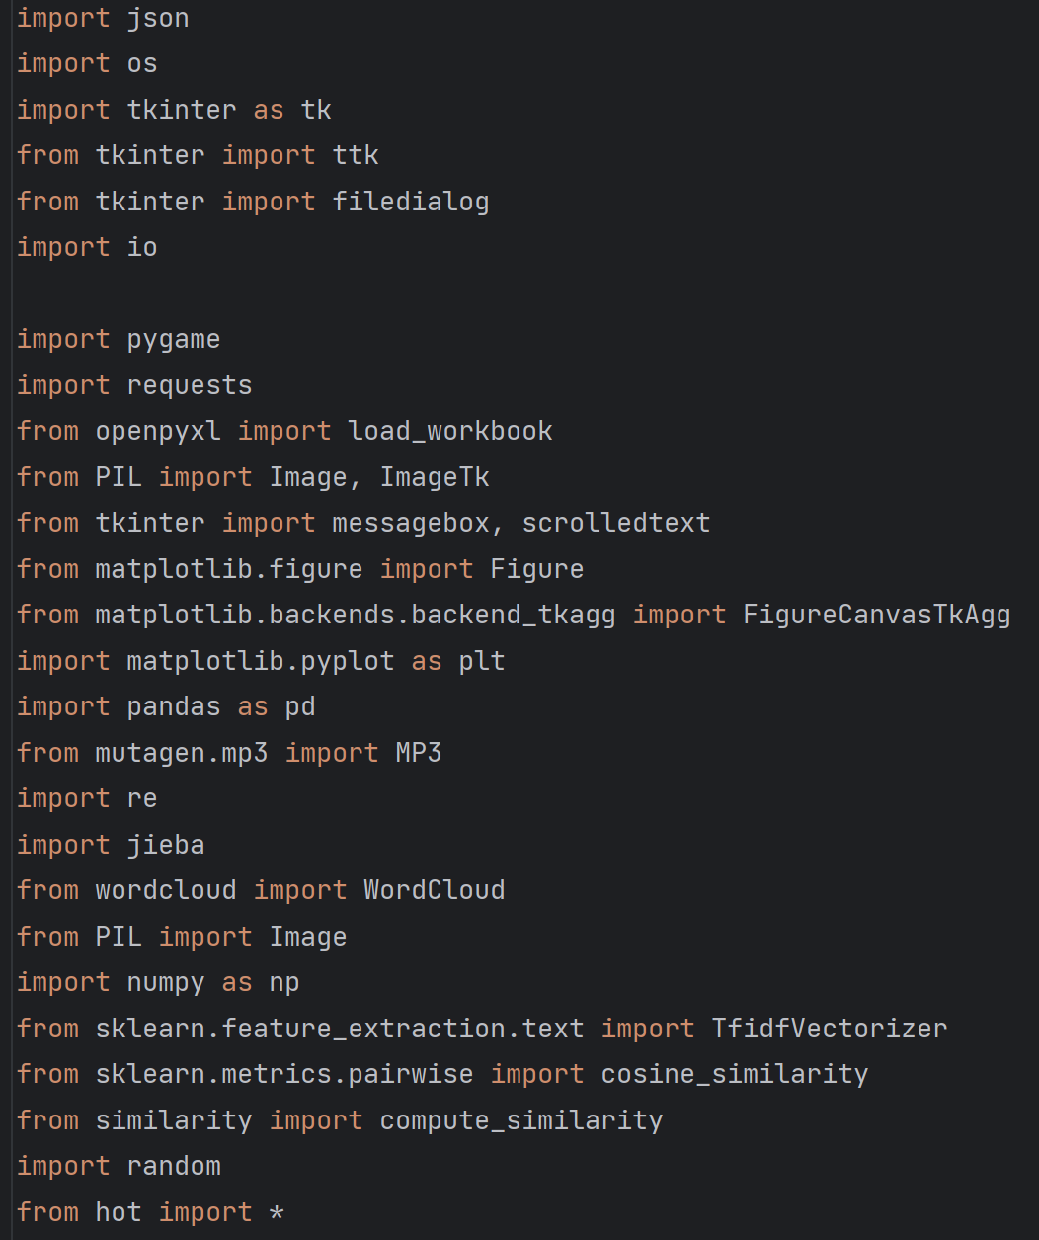

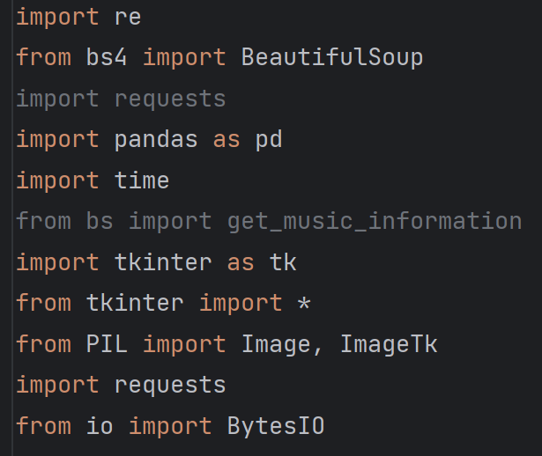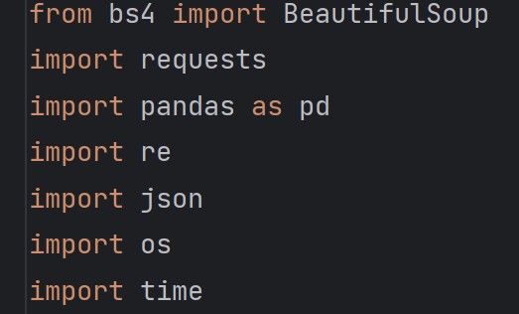

**Crawler step:**

1. Execute crawler.py and enter playlist id.



1. Crawling data.

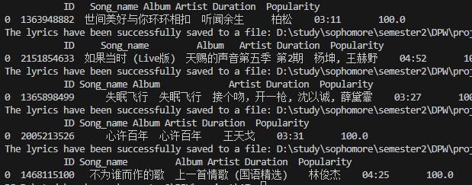

1. Get two output excel file

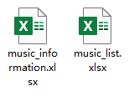

Music_information.xlsx contain all music information, and it can be loaded into th e GUI during the following step.

4.



In lyrics folder can store all lyrics txt file.

Note: The submitted code set has contained a playlist’s information and corresponding song’s lyrics, and you can directly use it and load into the GUI. But you can also run the crawler.py to get the song of other playlist.

**Interface preview**

Main interface

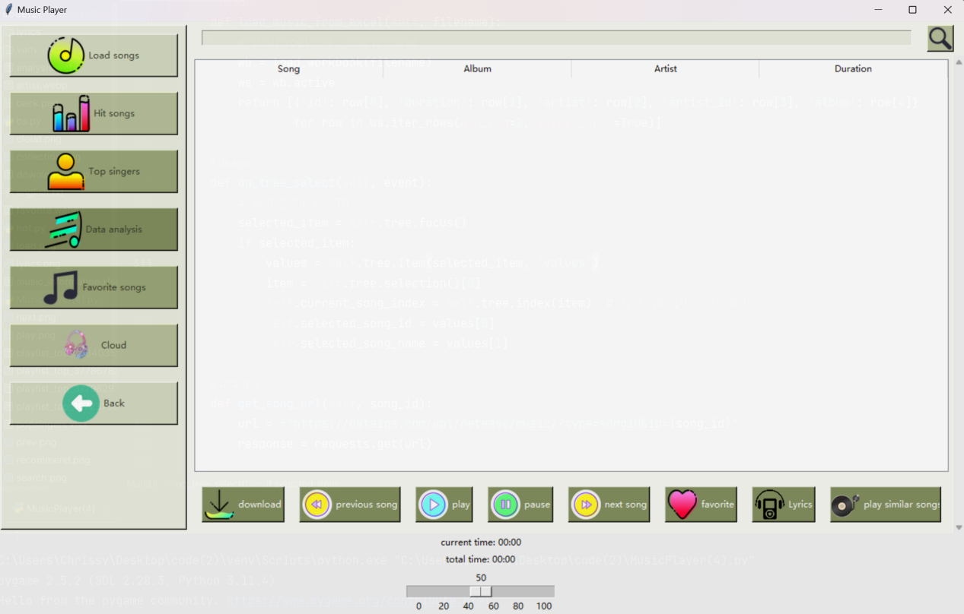

Crawler data presentation

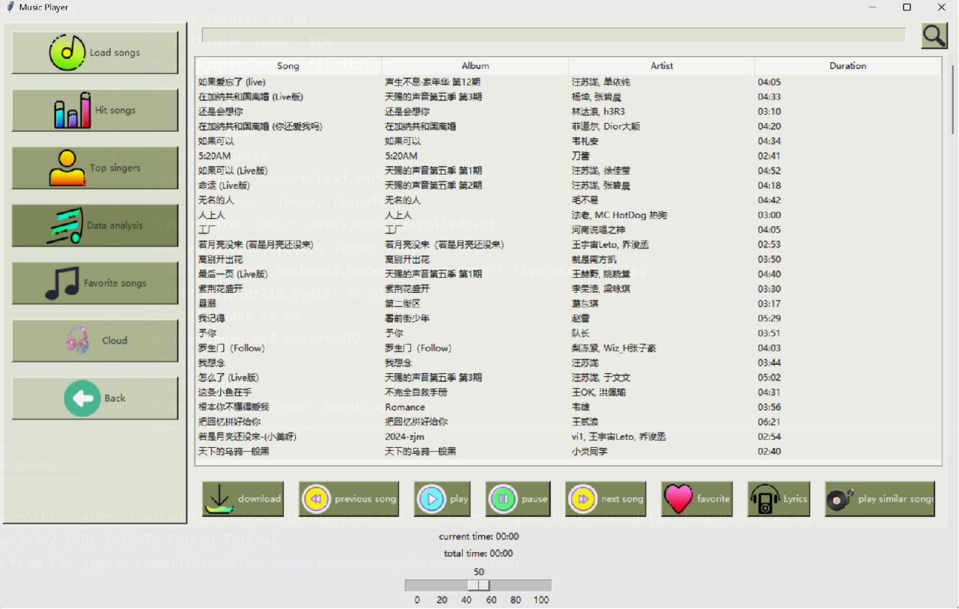

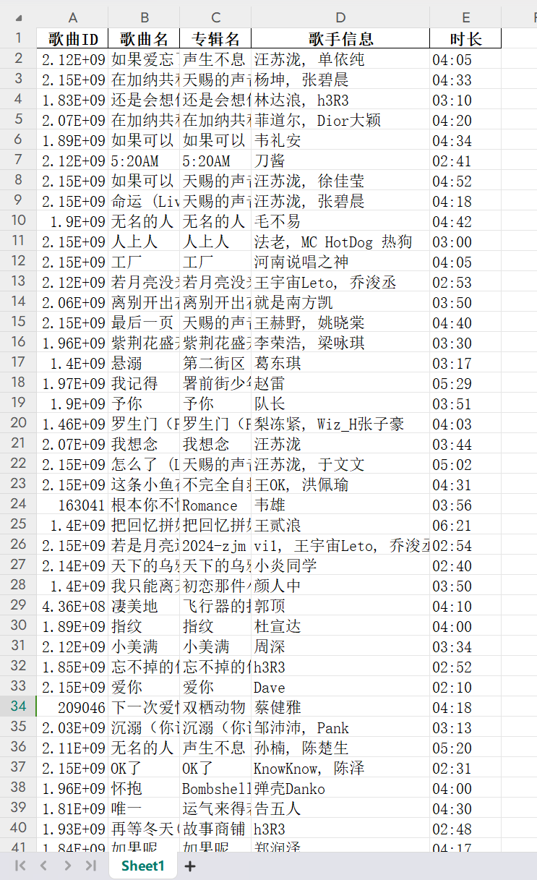

Data analysis presentation

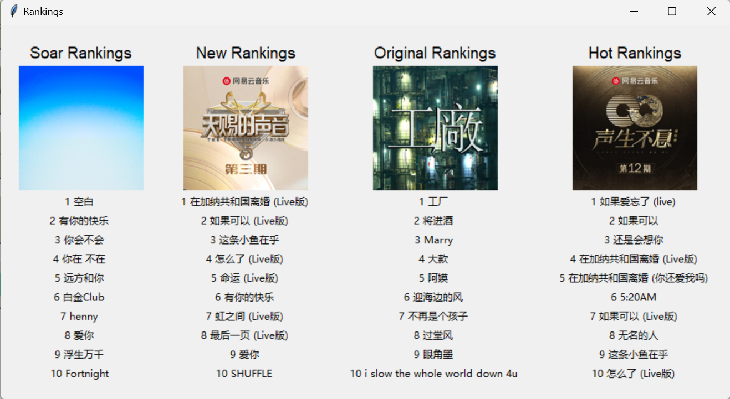

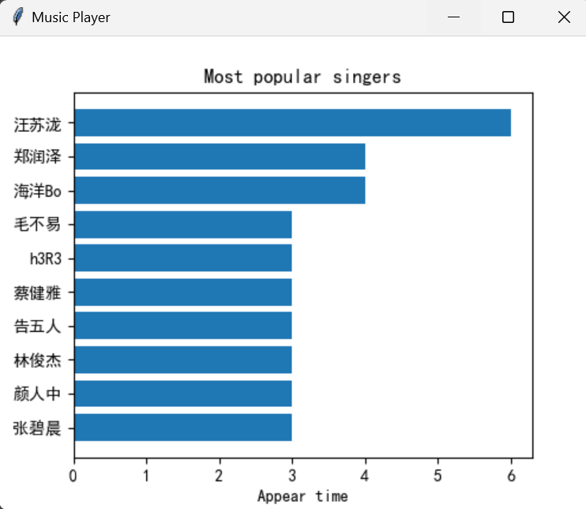

Lyrics cloud show



**Details**

1. The main interface is divided into three frames, the left is the function button interface, the upper right is the search box, the middle part of the right shows the crawled data, the lower right is the function button of the song, and the lower is the volume adjustment interface.
2. You can search for artist, album name, song or duration by using the search box on the interface.

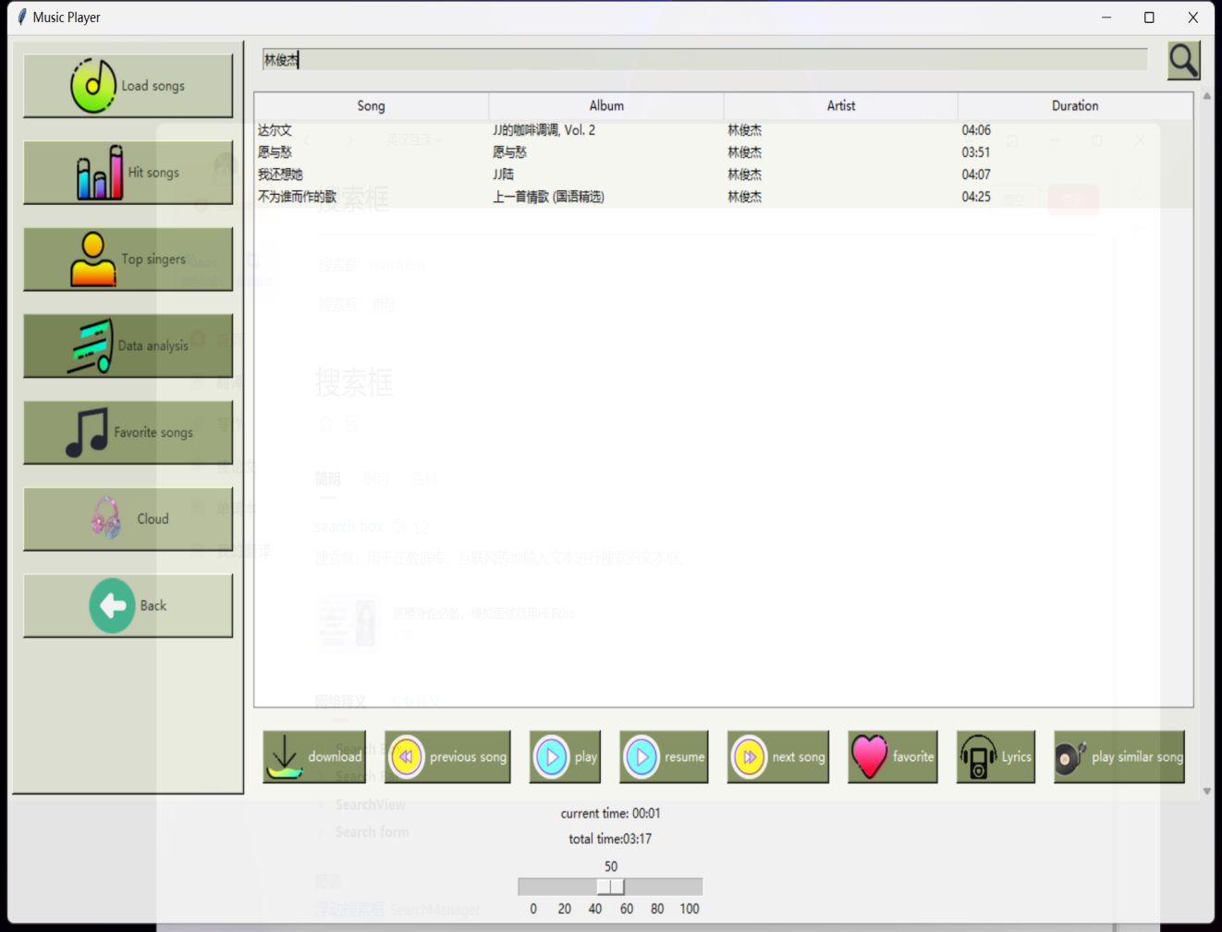

1. Click the song and perform the button operation below to achieve the corresponding functions (such as playing, pausing, favorites, next songs, etc.)

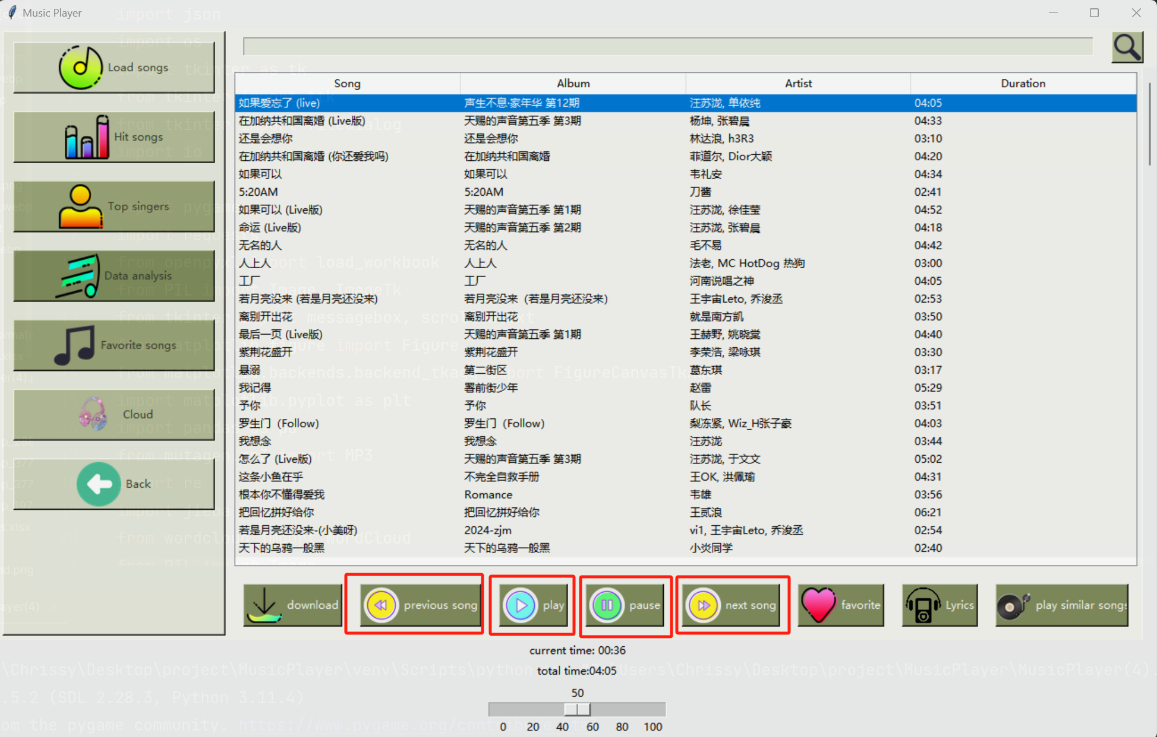

1. Click on favourite songs on the left to view your current user's favorite songs

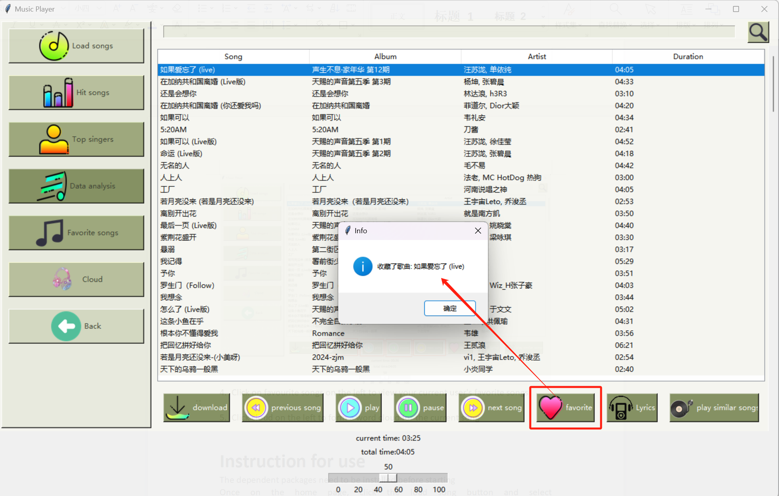

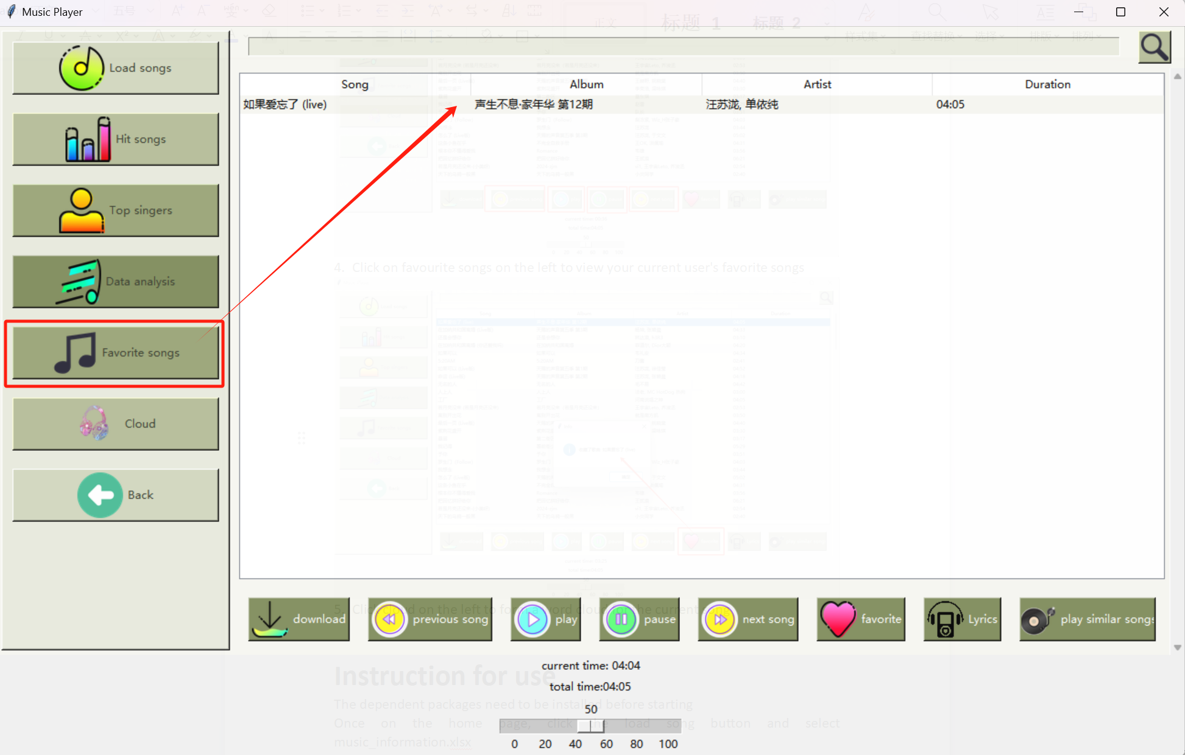

1. Click cloud on the left to form a word cloud for the current song

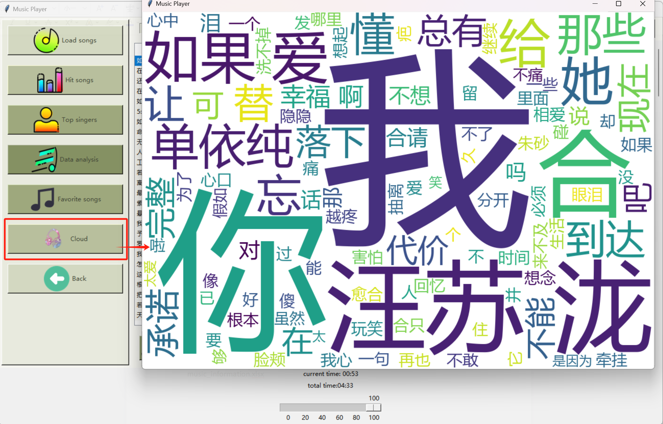

1. Click on a similar song to jump to another song that is similar in style to the current song

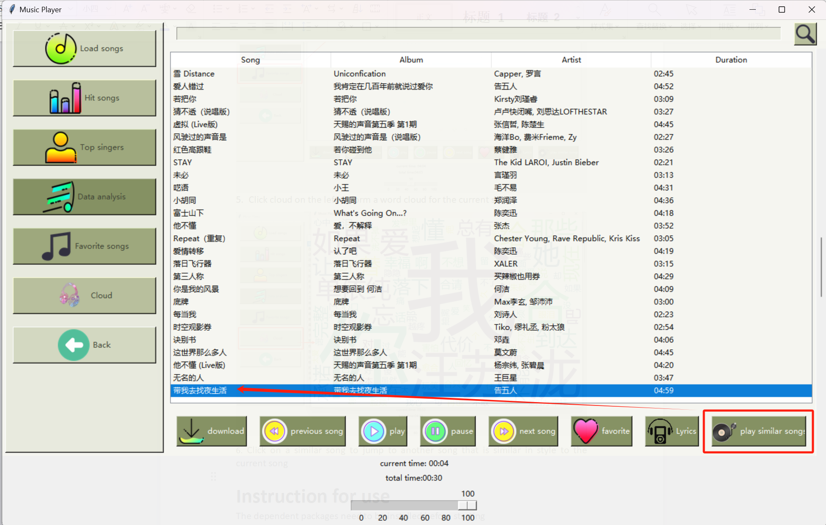

1. Click the Hot Songs chart to show the real-time music ranking on the network

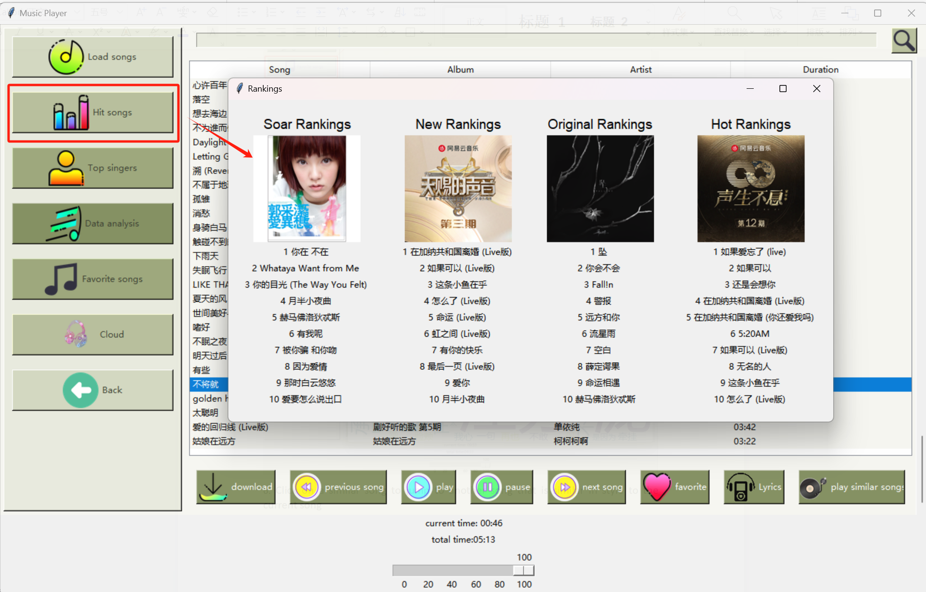

1. Click top singers to display the ranking of singers with the data set

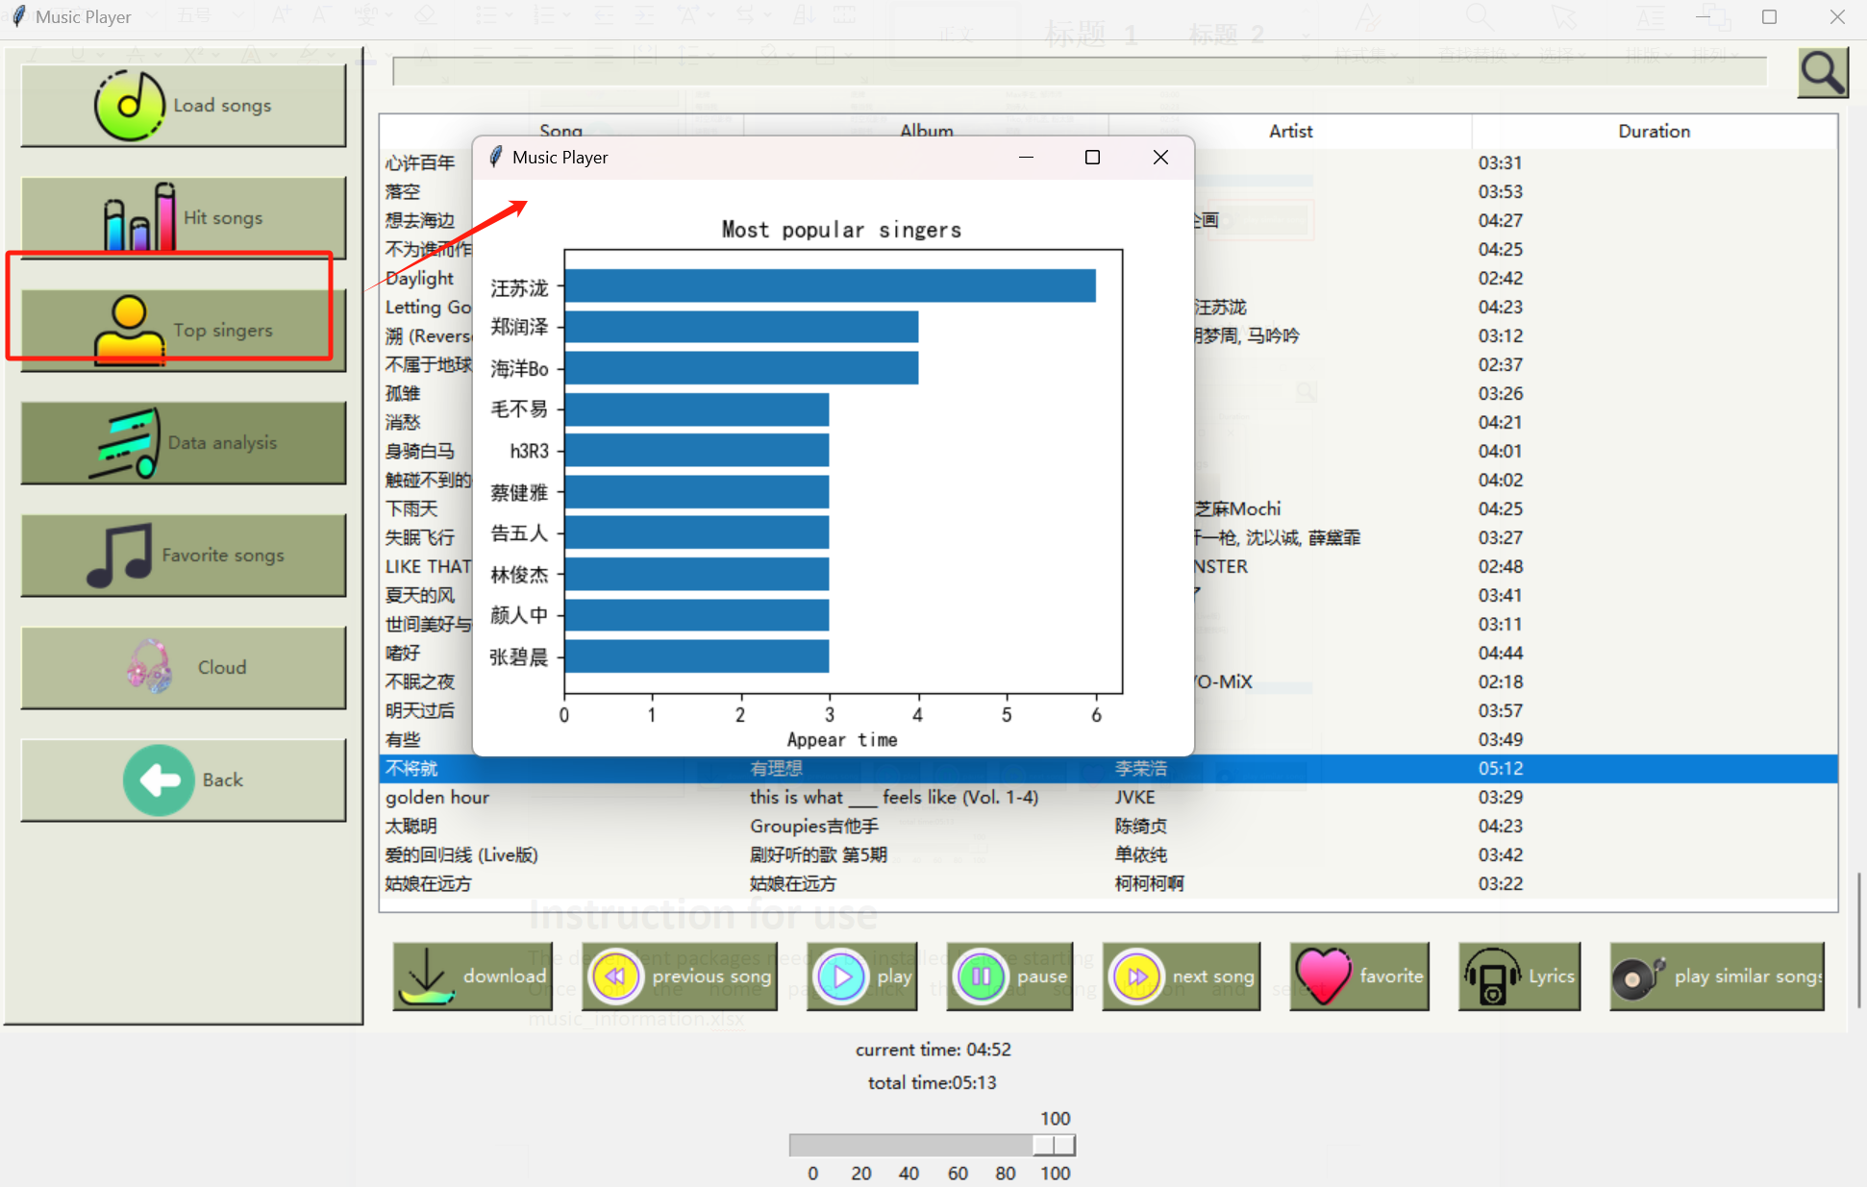

1. Click the Download button to save the music locally

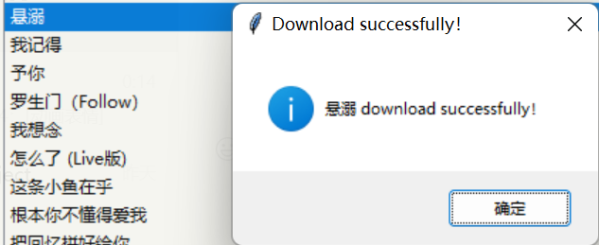

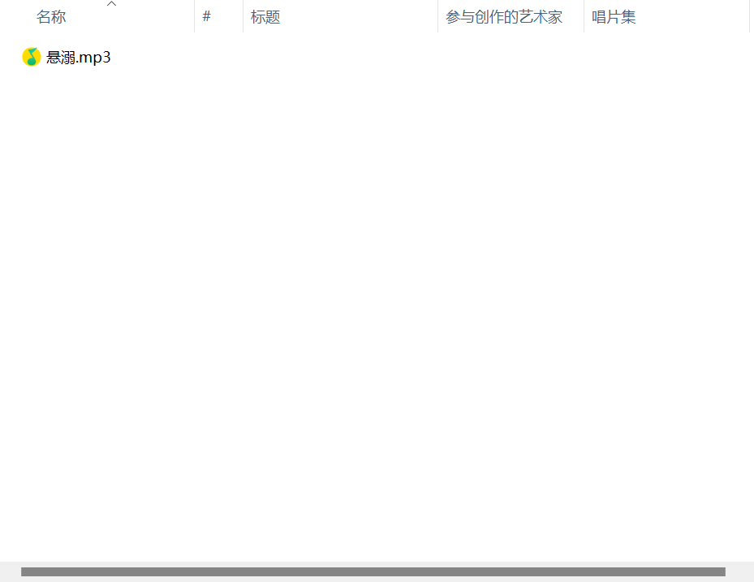

1. Display the data analysis page

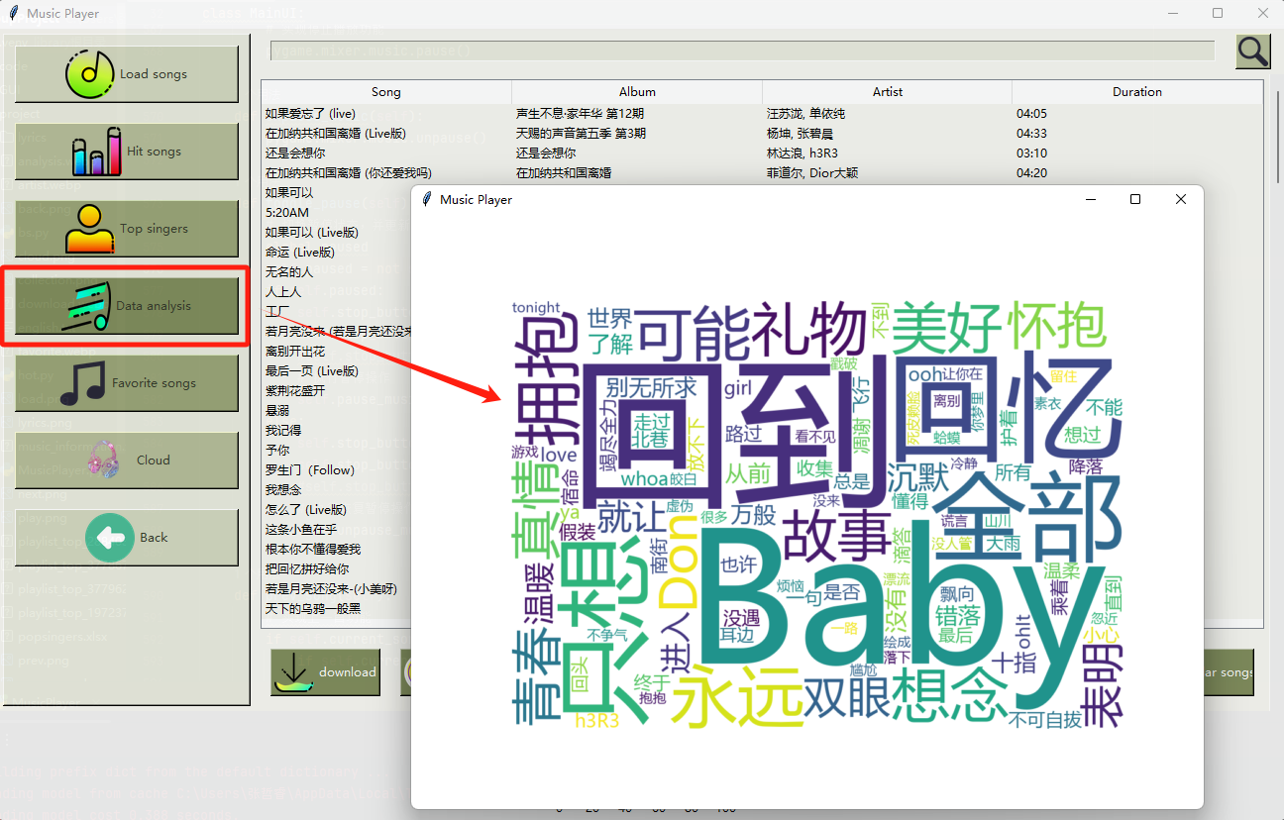

1. Adjust the volume and song duration display

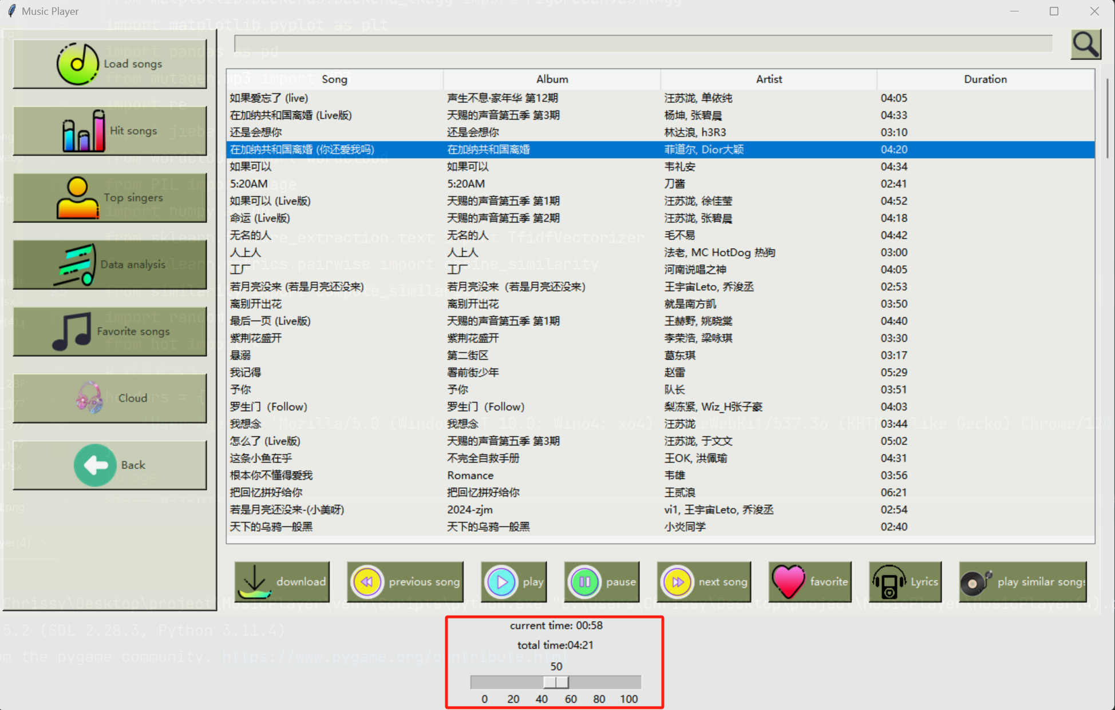

**Instruction for use**  
The dependent packages need to be installed before starting  
Once on the home page, click the load song button and select music_information.xlsx